SACRED HEART PARISH

Sacred Heart Parish Founded 1814, The First Catholic Parish in the STate of New Jersey

Sacred Heart Church, 343 South broad Street, Trenton, New Jersey 08608

Holy Cross Church, 233 Adeline Street, Trenton, New Jersey 08611

ALL ARE WELCOME

Whatever your present status in the Catholic Church, whatever your current family or marital situation,

Whatever your past or present religious affiliation, whatever your personal history, age, background, or

race, whatever your own self-image or esteem, you are invited, welcomed, accepted, loved and

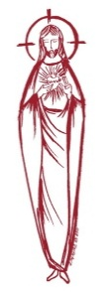
respected at the Parish of the Sacred Heart.

PASTOR

Rev. Msgr. Dennis A. Apoldite
frdennis@trentonsacredheart.org
PAROCHIAL VICAR
Rev. Charles Muorah
Felician Residence for Clergy
233 Adeline Street, Trenton, New Jersey 08611
609-393-4826 ext. 108 for Fr Charles
DEACON
Dr. Christian Nnajiofor
Business ADMINISTRATOR
ADMINISTRATIVE ASSISTANT
John DeSantis: secretary@trentonsacredheart.org
Administrator of religious education
Mary Tovar: reled@trentonsacredheart.org
COORDINATORS OF SACRED MUSIC
Natalie Megules ~ 609-575-6484
Rupert Peters ~ Gospel Mass 609-442-7871
MAINTENANCE DEPARTMENT
Frank Rios
Trustees
Jack Breuer and Ellieen Ancrum Ingbritsen,

OFFICE HOURS

9:00am – 4:00pm Monday – Friday

SACRED HEART PARISH OFFICE

343 South Broad Street, Trenton, NJ 08608

Phone: (609) 393-2801 ~ Fax: (609) 989-8997

WEB PAGE:

www.trentonsacredheart.org

CEMETERY RECORDS
Contact The Office of Catholic Cemeteries at 609-394-2017 or DirectorofCemeteries@DioceseofTrenton.org

SACRAMENTAL RECORDS
Sacred Heart Church, Saint John’s Church, Saint Francis Church, Saints Peter and Paul Church, Saint Stanislaus Church, Holy Cross Church, Blessed Sacrament Church, Our Lady of Divine Shepherd Church, Blessed Sacrament/Our Lady of Divine Shepherd Parish and Divine Mercy Parish.

Liturgy Schedule

Sacred Heart CHURCH
Monday, Tuesday, Wednesday and Friday
12:10 Noon
Saturday Evening 5:15 PM
Sunday Morning 9:00 and 11:15 AM
HOLY CROSS CHURCH
Monday, Thursday and Friday 8:00 AM
Saturday Evening 4:00 PM
Sunday Morning 10:00 AM Gospel
12:00 Noon Polish
For each Holy Day please reference the bulletin

SACRAMENTS
BAPTISM
Please call the Parish Office at least one month in advance.

RECONCILIATION

Every First Friday following the 12:10PM Mass SHC

Saturday afternoon ~ 4:30 to 5:00 PM SHC

Every Saturday from 3:30 to 3:50 PM HCC

Every Sunday 9:30 to 9:50AM HCC

and by appointment.
EUCHARISTIC ADORATION
First Saturday of the Month 2:30 to 3:30 pm
in Holy Cross Church
MARRIAGE
Please call the Parish Priest at least one year in advance to set up initial meeting and to confirm a wedding
date and time.
ANOINTING OF THE SICK
Please call the Priests any time 609-393-2801.
COMMUNION TO THE HOMEBOUND
Call the Parish Office to schedule home visit.
CONSIDERING PRIESTHOOD?
Email: Vocations@DioceseofTrenton.org

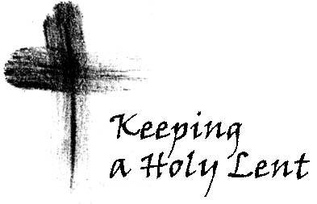

THIRD SUNDAY OF LENT

March 3,2024

MASS INTENTIONS
Saturday, March 2
4:00pm HCC~ Deceased Members of Jesencky Family
5:15 pm SHC ~ Betty O’Neill and Vito Erkoboni
Sunday, March 3
9:00 SH ~ Carmella Staub
10:00HCC~ The intentions of the People of the Parish
11:15 SH ~ Vladimir Chernichov & Mary Chernichov
12:00 HCC Polish ~ Maciej Sokolowski
Monday, March 4
8:00 HCC ~ Special Intentions
12:10 SHC~ Special Intentions
Tuesday, March 5
12:10 pm SHC ~ Eileen Kostrzewa
Wednesday, March 6
12:10 pm SHC ~ Wilma Ruberto
Thursday, March 7
8:00 am HCC ~ Helen Essky
Friday, March 8
8:00 am HCC ~ Theodore McCarrick
12:10 pm SHC ~ Joyce Reed
Saturday, March 9
4:00pm HCC~ Dolores Krysztofik and Ronald Carver
5:15 pm SHC ~ Ken & Lucille Fisher
and Concetta Vagott
Sunday, March 10
9:00 SH ~ The intentions of the People of the Parish
10:00HCC~ Special Intention
11:15 SH ~ Reinaldo Cruz, Joyce Reed,
and Patricia Romanowsky
12:00 HCC Polish ~ Maciej Sokolowski

OUR SICK LIST
Beth Fitzpatrick, Judy Brown, BJ Matthews, Marg Herpel, Jose Gonzalez, Mary Sokolowski, Rocco, Lorraine Wargo, Robert Paci, David Carver, Jennifer Lyons, Grace Profy, Steve Jurczynski, Cornell Hess, Ruby Covington, Judith Santigo, Dan Breese Jr, Brenna Kennedy-Moore, Mark Friedman, Alexander A. Ladnyk, Lauren Clayton, Joseph Edralin, Margie Tiongson, Vincent Cooper, Jr., Gail Ladnyk, Leo Genovesi, Richard Buckley, Tony Ragolia, Barbara Burrows, Charles Burrows, Dorothy Amoroso, Maryann Sullivan, Regina Friedman, Stanley Winowicz, Greg Schafer, Jack Hardiman, Amy Birk, Julia Grazioli, Matt Tydryszewski.

OUR DECEASED
Helen Smith, Eileen Sondej, and our friends at South Village, Riverside Nursing and Rehabilitation Center, Mill House and Waters Edge.
MINISTRY SCHEDULE
(Subject to Change)
Saturday, March 2
4:00pm HCC ~ Fr Charles L.: F. Zielinski Em.: A. Lennon
5:15pm Msgr. Dennis L.: L. Seabrook Em.: W. Lewis, M. Salamandra
Sunday, March 3
9:00 Msgr. Dennis L.: Y. Laurenti Em.: Komjathy, H. Mangan, G. Mowenn
10:00 HCC ~ Fr. Charles L.: R. Nnajiofor Em.: O. Nnadi
11:15 SHC ~ Msgr. Dennis L.: M. Rhodes Em.: N.Rhodes, T. Rizzuto
12:00 HCC Polish ~ TBA

Saturday, March 9
4:00pm HCC ~ Fr Charles L.: C. Benitez; Em.: R. Micharski
5:15pm Msgr. Dennis L.: K. Willever;Em.: A. Solack, B. DuMont
Sunday, March 10
9:00 Msgr. Dennis L.: K. Jurczynski; Em.: K. Myers, O. Nagbe, E. Wengryn
10:00 HCC ~ Fr. Charles L.: I. Nwachukwu; Em.: S. Nwachukwu
11:15 SHC ~ Msgr. Dennis L.: M. Tovar;Em.: A. Woloff, K. Parasimo
12:00 HCC Polish ~ TBA

WEEKLY COLLECTION
Last weekend’s collection amounted to $9,138.00. This includes the donations received in Church and the mail ins. Thank you for your continued support of our parish.

READINGS FOR THE WEEK
Third Week of Lent
Sunday Ex 20:1-17 1 Cor 1:22-25; Jn 2:13-25
Monday 2 Kgs 5:1-15ab; Lk 4:24-30
Tuesday Dn 3:25, 34-43; Mt 18:21-35
Wednesday Dt 4:1, 5-9; Mt 5:17-19
Thursday Jer 7:23-28; Lk 11:14-23
Friday Hos 14:2-10; Mk 12:28-34
Saturday Hos 6:1-6; Lk 18:9-14

PROMISE TO PROTECT
The Diocese of Trenton is committed to the norms of the U.S. Bishop’s Charter for the Protection of Children and Young People in regard to the reporting and investigation of sexual abuse allegations involving minors. If you have been sexually abused as a minor by anyone representing the Catholic Church, you can report that abuse through the diocesan Hotline: 1-888-296-2965 or abuseline@dioceseoftrenton.org. Allegations are reported to the appropriate law enforcement agencies.

ADORATION
of the Blessed Sacrament will take place on Saturday March 2nd , in Holy Cross Church at 2:30 pm. All are welcome to come and pray .

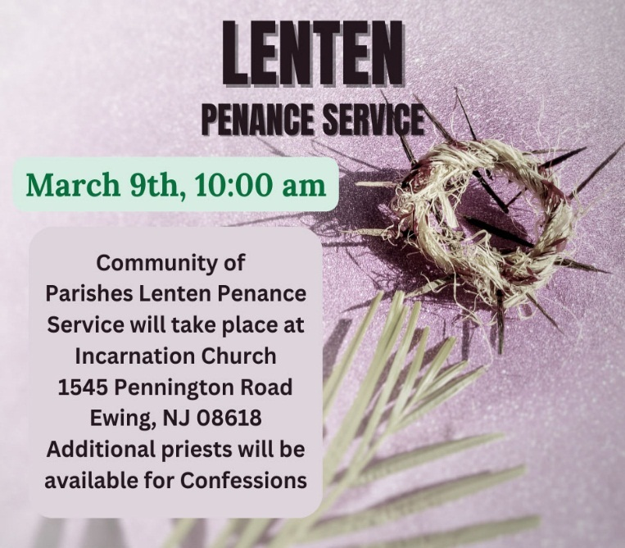

LENTEN PENANCE SERVICE
On Saturday Morning, March 9th at 10:00am our Annual Lenten Penance Service will take place in Incarnation Church. Please take this opportunity to be reconciled through the Sacrament.
RCIA ~ THE FIRST SCRUTINY
The O.C.I.A. Candidates will be gathering at the 11:15AM Mass this weekend, for the First Scrutiny. The prayers offered during this Rite will assist and strengthen them for full conversion and specifically to battle the influence of the evil one.
These are ancient rites and they may, at first, seem strange to us. But they are profoundly rooted in our human experience. We need to examine (scrutinize) how we are, the areas of our lives where we are tempted. We really need healing and the strength that can come from the support of our sisters and brothers.
ALTAR ROSARY SOCIETY
All rosarians, future rosarians, people of our parish are warmly welcomed to join us this Sunday, March 3rd , 9:00am Mass at Sacred Heart Church. The rosary will be prayed before Mass. Following Mass, a meeting will take place at Toomey Hall. Stop by, meet the members and enjoy light refreshments. We are a church support group of dedicated Catholic people who serve our Blessed Mother, our Parish. Hear about the good the Rosarians do for our parish community. God Bless you all. We are looking forward to your participation. Any questions, please call Joan Buckley @ 609-396-7063.
WELCOME MT.CARMEL GUILD
Our Sacred Heart Parish is proud to host the
Mt. Carmel Guild’s Founders Day Mass,
Sunday, March 10th, at 1:00 PM,
Bishop David M. O’Connell, CM, will be the Celebrant of the Mass. All are welcome to attend. For more information, please visit www.MtCarmelGuild.org or
call 609.392.5129 ext. 111

FIRST PENANCE
Nine children of our parish received their Sacrament of Reconciliation this Saturday. Our Parish Family congratulations them and offers our prayers and support as they now prepare to receive their First Holy Communion in May.
Please keep them in your prayers.

LENT
MERCER COUNTY LENTEN PILGRIMAGE
Week of March 3, 2024
The Mercer County Lenten Pilgrimage Schedule for this week includes:
During this Lenten Season you are invited to journey to some of the Churches throughout Mercer County to celebrate Mass and get to visit some of the beautiful churches of Mercer County.
This week’s Station churches are:
Tuesday, March 5 St. David the King (7:00 PM) 1 New Village Road, Princeton Junction, NJ
Wednesday, March 6 St. James (7:00 PM)
11 E Paul Ave, Trenton, NJ
Thursday, March 7 Holy Cross Church (7:00 PM) 227 Adeline Street, Trenton, NJ
Friday, March 8 Our Lady of Good Counsel
(6:00 PM)137 W. Upper Ferry Road, West Trenton, NJ

STATION CHURCH MASS AT HOLY CROSS
As part of our Mercer County Lenten Program, we will have a Mass in Holy Cross Church this Thursday, March 7th at 7:00 in the evening. All of the parishes of Mercer County have been invited. We encourage you, if your schedule permits, to join us as we welcome our county members to our Parish. All are welcomed.

THIRD WEEK OF LENT
March 3 THIRD SUNDAY OF LENT
Ex 20: 1-17 1Cor 1:22-25 Jn 2:13 - 25
~Sacred Heart Church: Mass celebrated
at 9:00am and 11:15
~Stations prayed after the 9:00am Mass ~Holy Cross Church: Mass celebrated at 10:00am (Gospel Mass) 12:00 Noon (Polish Mass)
The Lamentations will follow the Mass

March 4 ~ Monday Lenten Weekday
Kgs 5:1-15 Ps 42 Luke 4:24 - 30
~Holy Cross Church Mass celebrated at 8:00am
Sacred Heart Mass celebrated at 12:10 noon ~
Saints for Sinners program following the Mass in 1 Centre Street, this week’s video is:
Saint Albert Chmielowski

March 5 ~ Tuesday Lenten Weekday
Dn 3:25, 34-43/Mt 18:21-35
~ Sacred Heart Church Mass celebrated at 12:10 noon ~ Rosary prayed after Mass ~ Sacred Heart Church Confessions 5:00 pm to 6:00pm. ~Mercer County Lenten Pilgrimage at St. David the King Church 7:00 PM ~ 1 New Village Road, Princeton Junction,

March 6 ~ Wednesday Lenten Weekday
Dt 4:1, 5-9/Mt 5:17-19
~Sacred Heart Mass celebrated at 12:10 noon
~Holy Cross Church confessions
5:00pm to 6:00pm
~Mercer County Pilgrimage at St. James Church
7:00 PM ~11 E Paul Ave, Trenton,

March 7 ~ Thursday Lenten Weekday
Jer 7:23-28/Lk 11:14-23
~Holy Cross Church Mass celebrated at 8:00am
~Mercer County Lenten Pilgrimage at
Holy Cross Church
7:00 PM ~ 215 Adeline Street, Trenton,

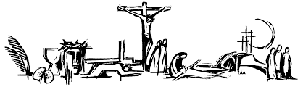

March 8 ~ Friday Lenten Weekday
Hos 14: 2-10 Ps 81 MK 12:28-34
~Day of Abstinence ~ Mass celebrated at 8:00 am at Holy Cross Church ~Mass celebrated at 12:10 noon at Sacred Heart Church ~Stations of the Cross at 12:00 noon at Holy Cross Church ~ Stations of the Cross in Polish at 6:30 pm at Holy Cross Church ~Mercer County Lenten Pilgrimage at Our Lady of Good Counsel Church
6:00 PM ~137 W. Upper Ferry Rd, Ewing~ Holy Name Society Adoration of the Blessed Sacrament from

March 9 ~Saturday Lenten Weekday
Hos 6:1-6/Lk 18:9-14
~ LENTEN PENANCE SERVICE at 10:00am will be held in Incarnation Church ~ Lenten Program: Jesus ACTion will be held in Toomey Hall under Sacred Heart Church from 10:00am to 11:30 am ~Confessions at Holy Cross Church from 3:30 to 3:50 pm ~ Mass celebrated at 4:00 pm at Holy Cross Church ~ Confessions at Sacred Heart Church from 4:30 to 5:00 pm ~ Mass celebrated at 5:15 pm at Sacred Heart Church

STATIONS OF THE CROSS
The Stations of the Cross will be prayed every Friday at 12:00 noon at Holy Cross Church and every Sunday following the 9:00 Mass at Sacred Heart. Stations of the Cross will be prayed in Polish on Friday evenings at 6:30pm in Holy Cross Church.

CATHOLIC RELIEF SERVICES

SECOND ENVELOPE NEXT WEEKEND
Every gift you give helps a child thrive, brings hope to a family and rebuilds a community. When you give, you help fill the bellies of young children so they can study hard in school. You help mothers and babies around the world receive nutritional care and health exams. Farmers learn innovative ways to plant and grow crops despite drought or disease. And women find dignity in opportunities for savings and training. You can make an immediate lifesaving difference and give hope to children, mothers and fathers around the world.

